**PROJECT : SMART PUBLIC RESTROOMS**

**AUTOMATIC DOOR SYSTEM**

**Components**:

* Arduino UNO
* Servo motor
* IR sensor
* Red and green LEDs
* 220 ohm resistor
* Jumper wires and a breadboard
* USB cable for uploading the code

**Circuit**:

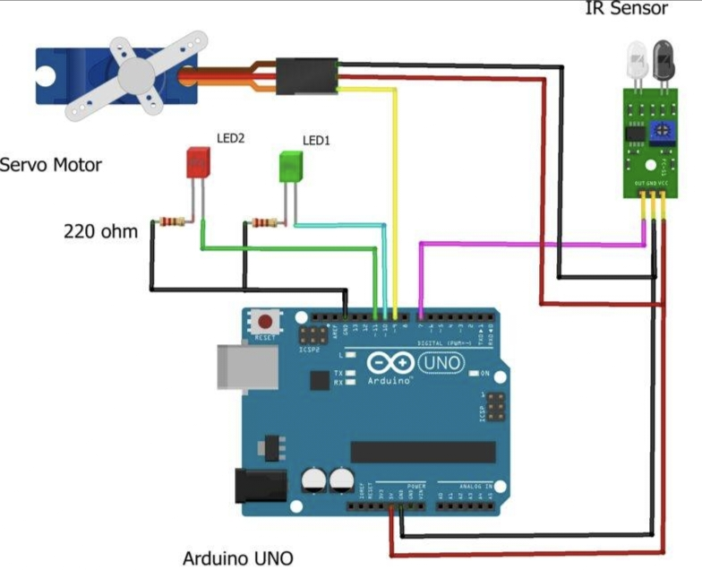

**Code**:

#include <Servo.h>

Servo s1;

Int val = 0 ;

Void setup()

{

Serial.begin(9600); // sensor buart rate

S1.attach(3);

pinMode(2,INPUT);

pinMode(5,OUTPUT); // led green pin

pinMode(6,OUTPUT); // led red pin

}

Void loop()

{

Val = digitalRead(2); // IR sensor output pin connected

Serial.println(val); // see the value in serial mpnitor in Arduino IDE

Delay(1);

If(val == 1 )

{

digitalWrite(5,HIGH); // LED ON

digitalWrite(6,LOW); // LED OFF

s1.write(90);

delay(2000);

}

Else

{

digitalWrite(5,LOW); // LED OFF

digitalWrite(6,HIGH); // LED ON

s1.write(0);

}

}

**AUTOMATIC ROOM LIGHTING SYSTEM**

**Components**:

* Arduino
* Arduino UNO [Buy Here]
* PIR Sensor
* 5V Relay Module (Relay Board)
* LED
* 100Ω Resistor (1/4 Watt)
* Connecting Wires
* Breadboard
* Power Supply

**Circuit**:

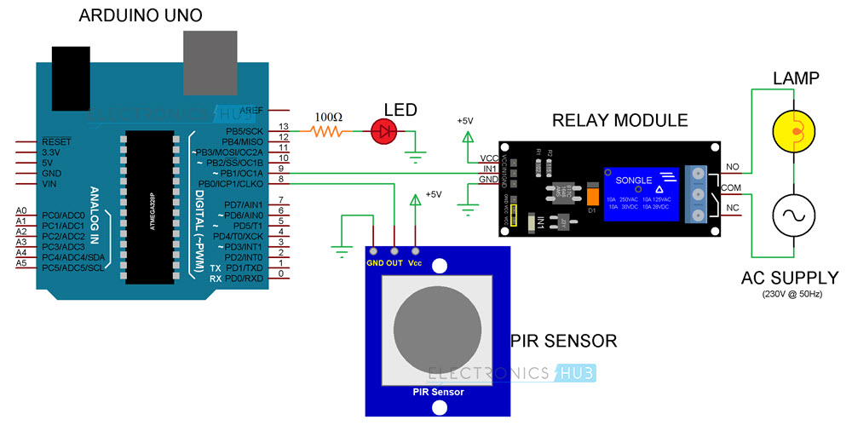

**Code**:

Int in1 = 9;

Int sensor = 8;

Int led = 13;

Unsigned long t=0;

Void setup()

{

Serial.begin(9600);

pinMode(in1, OUTPUT);

pinMode(sensor, INPUT);

pinMode(led, OUTPUT);

digitalWrite(in1,HIGH);

digitalWrite(led,LOW);

while(millis()<13000)

{

digitalWrite(led,HIGH);

delay(50);

digitalWrite(led,LOW);

delay(50);

}

digitalWrite(led,LOW);

}

Void loop()

{

digitalWrite(in1,HIGH);

digitalWrite(led,LOW);

if(digitalRead(sensor)==HIGH)

{

T=millis();

While(millis()<(t+5000))

{

digitalWrite(in1,LOW);

digitalWrite(led,HIGH);

if((millis()>(t+2300))&&(digitalRead(sensor)==HIGH))

{

T=millis();

}

}

}

}

**WATER LEVEL MONITORING AND CONTROL SYSTEM:**

**Components**:

* NodeMCU ESP8266 WiFi Module
* JSN-SR04T Ultrasonic Sensor
* 0.96” I2C OLED Display
* Hi-Link 220V AC to 5V DC Converter
* Push Button Switch
* 5V Relay Module
* AC Water Pump
* Pipes 2 meter or more
* Zero PCB Board

**Circuit**:

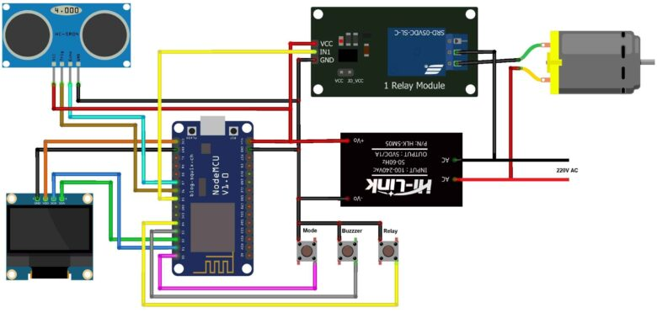

**Code**:

A cloud storage is used at blynk.cloud

The follow is the complete code for IoT ESP8266 Based Ultrasonic Water Level Monitoring System. The code is written in Arduino IDE.

There are few changes that you need to make before uploading this code to the Esp8266 Board.

From the following lines change the Blynk Authentication Token.

#define BLYNK_TEMPLATE_ID “***************”

#define BLYNK_TEMPLATE_NAME “**********************”

#define BLYNK_AUTH_TOKEN “*************************”

Replace the WiFi SSID and Password from the following lines.

Char ssid[] = “****************”;

Char pass[] = “**************”;

After making these changes, you can now upload the code to the ESP8266 Board.

#include <Adafruit_SSD1306.h>

#include <ESP8266WiFi.h>

#include <BlynkSimpleEsp8266.h>

#include <AceButton.h>

#define BLYNK_TEMPLATE_ID “***************”

#define BLYNK_TEMPLATE_NAME “**********************”

#define BLYNK_AUTH_TOKEN “*************************”

Char ssid[] = “****************”;

Char pass[] = “**************”;

Int emptyTankDistance = 160;

Int fullTankDistance = 20;

Int triggerPer = 20;

Using namespace ace_button;

#define TRIG 12 //D6

#define ECHO 13 //D7

#define Relay 14 //D5

#define BP1 2 //D0

#define BP2 13 //D3

#define BP3 15 //D4

#define V_B_1 V1

#define V_B_3 V3

#define V_B_4 V4

#define SCREEN_WIDTH 128

#define SCREEN_HEIGHT 32

#define OLED_RESET -1

Adafruit_SSD1306 display(SCREEN_WIDTH, SCREEN_HEIGHT, &Wire, OLED_RESET);

Float duration;

Float distance;

Int waterLevelPer;

Bool toggleRelay = false;

Bool modeFlag = true;

String currMode;

Char auth[] = BLYNK_AUTH_TOKEN;

ButtonConfig config1;

AceButton button1(&config1);

ButtonConfig config2;

AceButton button2(&config2);

ButtonConfig config3;

AceButton button3(&config3);

Void handleEvent1(AceButton*, uint8_t, uint8_t);

Void handleEvent2(AceButton*, uint8_t, uint8_t);

Void handleEvent3(AceButton*, uint8_t, uint8_t);

BlynkTimer timer;

Void checkBlynkStatus() {

Bool isconnected = Blynk.connected();

If (isconnected == false) {

}

If (isconnected == true) {

}

}

BLYNK_WRITE(VPIN_BUTTON_3) {

modeFlag = param.asInt();

if (!modeFlag && toggleRelay) {

digitalWrite(Relay, LOW);

toggleRelay = false;

}

currMode = modeFlag ? “AUTO” : “MANUAL”;

}

BLYNK_WRITE(VPIN_BUTTON_4) {

If (!modeFlag) {

toggleRelay = param.asInt();

digitalWrite(Relay, toggleRelay);

} else {

Blynk.virtualWrite(V_B_4, toggleRelay);

}

}

BLYNK_CONNECTED() {

Blynk.syncVirtual(V_B_1);

Blynk.virtualWrite(V_B_3, modeFlag);

Blynk.virtualWrite(V_B_4, toggleRelay);

}

Void displayData() {

Display.clearDisplay();

Display.setTextSize(3);

Display.setCursor(30, 0);

Display.print(waterLevelPer);

Display.print(“ “);

Display.print(“%”);

Display.setTextSize(1);

Display.setCursor(20, 25);

Display.print(currMode);

Display.setCursor(95, 25);

Display.print(toggleRelay ? “ON” : “OFF”);

Display.display();

}

Void measureDistance() {

digitalWrite(TRIG, LOW);

delayMicroseconds(2);

digitalWrite(TRIG, HIGH);

delayMicroseconds(20);

digitalWrite(TRIG, LOW);

duration = pulseIn(ECHO, HIGH);

distance = ((duration / 2) * 0.343) / 10;

if (distance > (fullTankDistance – 15) && distance < emptyTankDistance) {

waterLevelPer = map((int)distance, emptyTankDistance, fullTankDistance, 0, 100);

Blynk.virtualWrite(V_B_1, waterLevelPer);

If (waterLevelPer < triggerPer) {

If (modeFlag) {

If (!toggleRelay) {

digitalWrite(Relay, HIGH);

toggleRelay = true;

Blynk.virtualWrite(V_B_4, toggleRelay);

}

}

}

If (distance < fullTankDistance) {

If (modeFlag) {

If (toggleRelay) {

digitalWrite(Relay, LOW);

toggleRelay = false;

Blynk.virtualWrite(V_B_4, toggleRelay);

}

}

}

}

displayData();

delay(100);

}

Void setup() {

Serial.begin(9600);

pinMode(ECHO, INPUT);

pinMode(TRIG, OUTPUT);

pinMode(Relay, OUTPUT);

pinMode(BP1, INPUT_PULLUP);

pinMode(BP2, INPUT_PULLUP);

pinMode(BP3, INPUT_PULLUP);

digitalWrite(Relay, HIGH);

config1.setEventHandler(button1Handler);

config2.setEventHandler(button2Handler);

config3.setEventHandler(button3Handler);

button1.init(BP1);

button2.init(BP2);

button3.init(BP3);

currMode = modeFlag ? “AUTO” : “MANUAL”;

if (!display.begin(SSD1306_SWITCHCAPVCC, 0x3C)) {

Serial.println(F(“SSD1306 allocation failed”));

For (;;)

;

}

Delay(1000);

Display.setTextSize(1);

Display.setTextColor(WHITE);

Display.clearDisplay();

WiFi.begin(ssid, pass);

Timer.setInterval(2000L, checkBlynkStatus);

Timer.setInterval(1000L, measureDistance);

Blynk.config(auth);

Delay(1000);

Blynk.virtualWrite(V_B_3, modeFlag);

Blynk.virtualWrite(V_B_4, toggleRelay);

Delay(500);

}

Void loop() {

Blynk.run();

Timer.run();

Button1.check();

Button3.check();

If (!modeFlag) {

Button2.check();

}

}

Void button1Handler(AceButton* button, uint8_t eventType, uint8_t buttonState) {

Serial.println(“EVENT1”);

Switch (eventType) {

Case AceButton::kEventReleased:

If (modeFlag && toggleRelay) {

digitalWrite(Relay, LOW);

toggleRelay = false;

}

modeFlag = !modeFlag;

currMode = modeFlag ? “AUTO” : “MANUAL”;

Blynk.virtualWrite(V_B_3, modeFlag);

Break;

}

}

Void button2Handler(AceButton* button, uint8_t eventType, uint8_t buttonState) {

Serial.println(“EVENT2”);

Switch (eventType) {

Case AceButton::kEventReleased:

If (toggleRelay) {

digitalWrite(Relay, LOW);

toggleRelay = false;

} else {

digitalWrite(Relay, HIGH);

toggleRelay = true;

}

Blynk.virtualWrite(V_B_4, toggleRelay);

Delay(1000);

Break;

}

}

Void button3Handler(AceButton* button, uint8_t eventType, uint8_t buttonState) {

Serial.println(“EVENT3”);

Switch (eventType) {

Case AceButton::kEventReleased:

Break;

}

}